Deployed Monitoring Solution Evidence
This document shows that the Innovatech monitoring solution is deployed and working, and includes the dashboard with the key metrics. The solution is Prometheus and Grafana on a dedicated monitoring server in the private monitoring subnet.

1. Monitoring Server (Terraform)

1.1 IAM Role: Least Privilege
The monitoring server has its own IAM role, separate from the web and database servers. It has three permissions:
• AmazonSSMManagedInstanceCore: administrators reach the server through Session Manager, with no SSH and no open ports.
• ec2:DescribeInstances: read-only, lets Prometheus find the servers it has to monitor. This action cannot be limited to specific resources, so Resource is "*".
• ssm:GetParameter on the Grafana admin password only: the server cannot read any other secret, including the database passwords.
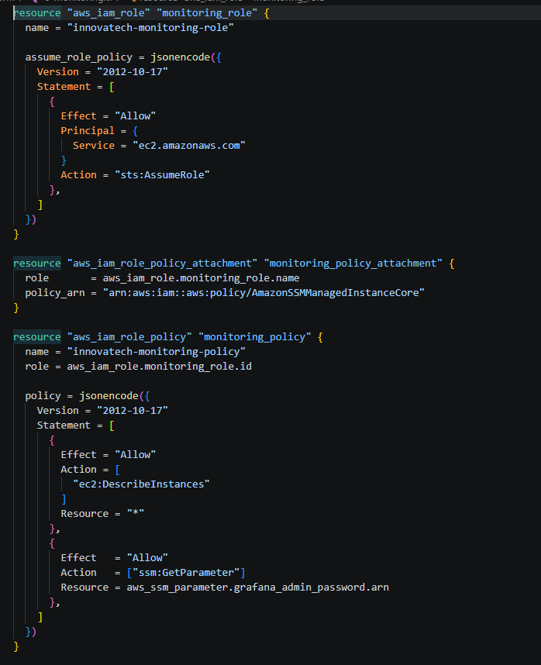
Figure 1: 6-monitoring.tf: monitoring IAM role and its permissions

1.2 Monitoring Instance
The monitoring server is a t3.small EC2 instance in the monitoring subnet of the Internal VPC. Its security group has no inbound rules: nothing can connect to it, and administrators use an SSM tunnel instead. Like the other servers, it requires IMDSv2 and has an encrypted disk.
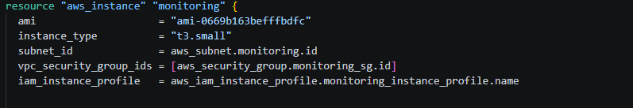
Figure 2: 6-monitoring.tf: monitoring instance placement, security group and role

1.3 Automated Installation: Prometheus
The user_data script installs everything on first boot. It downloads Prometheus 3.15.0, retrying if GitHub is briefly unreachable, and runs it as its own unprivileged prometheus user. The scrape configuration (prometheus.yml) is copied from the repository onto the server. Prometheus runs as a systemd service that restarts if it fails, and keeps 15 days of metrics.
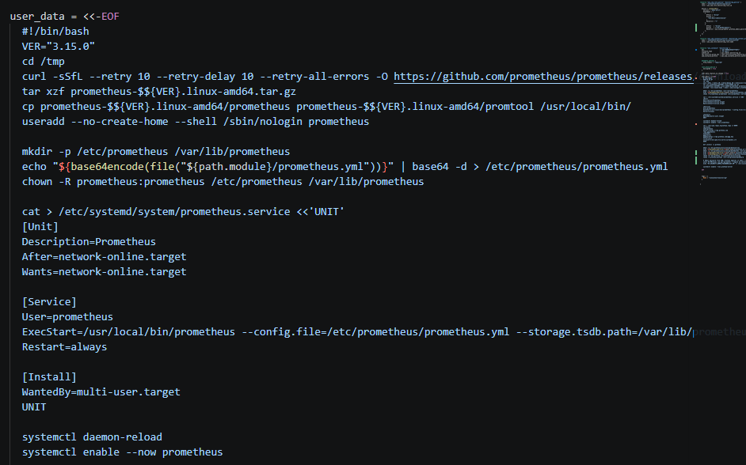
Figure 3: 6-monitoring.tf: user_data installing Prometheus with the repository's prometheus.yml

1.4 Automated Installation: Grafana, Data Source, Dashboard and Password
The second part of the script installs Grafana from its official package repository. It then copies three files from the repository onto the server: the data source (grafana.yml), the dashboard provider (grafana-dashboards.yml) and the dashboard itself (grafana-dashboard.json). Finally it reads the admin password from SSM Parameter Store and gives it to Grafana before Grafana first starts. As a result, the default admin/admin login never works, and the dashboard is available as soon as Grafana starts.
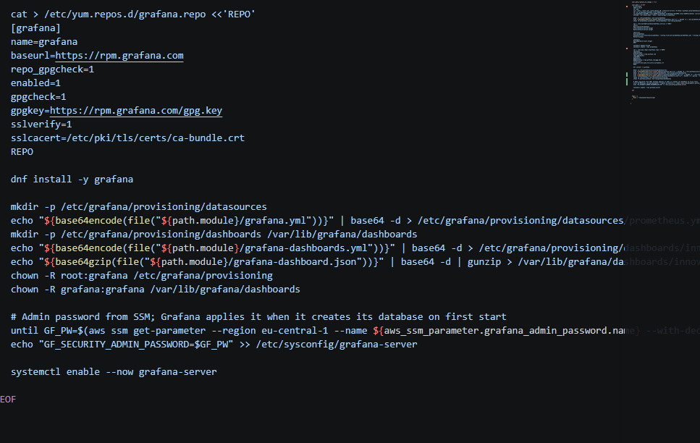
Figure 4: 6-monitoring.tf: user_data installing Grafana and provisioning its data source, dashboard and password

2. Configuration Files

2.1 Prometheus Scrape Configuration
prometheus.yml defines what is monitored. Prometheus collects metrics every 60 seconds from three jobs:
• prometheus: Prometheus monitors itself.
• web: all running EC2 instances tagged Name=innovatech-web, on node_exporter port 9100.
• db: the running instance tagged Name=innovatech-db, on port 9100.
The web and db jobs use EC2 service discovery instead of fixed IP addresses. Web servers are created and removed by the Auto Scaling group, and each gets a new IP. Prometheus finds new servers by their tag, so they are monitored automatically after scaling or replacement. A relabelling rule names each target by its EC2 instance ID, so graphs and the AWS console use the same identifier.
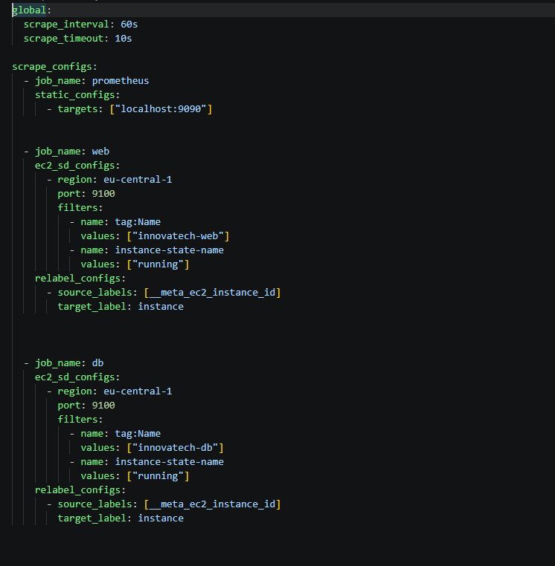
Figure 5: prometheus.yml: scrape jobs with EC2 tag-based discovery

2.2 Grafana Data Source
This file connects Grafana to Prometheus on the same server (http://localhost:9090) and makes it the default data source. It has a fixed ID (uid: prometheus) so the dashboard can refer to it reliably after every rebuild.
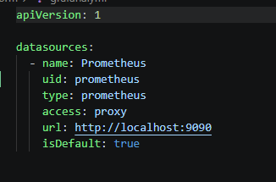
Figure 6: grafana.yml: provisioned Prometheus data source

2.3 Dashboard Provider
This file tells Grafana to load every dashboard file from /var/lib/grafana/dashboards into an "Innovatech" folder at startup. allowUiUpdates is false, so the repository stays the single source of truth: changes are made in code, not by clicking in the UI.
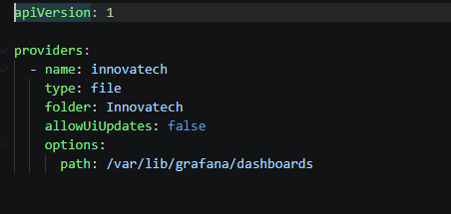
Figure 7: grafana-dashboards.yml: dashboard provider configuration

2.4 Dashboard as Code
The Innovatech Overview dashboard is a JSON file in the repository. It has 12 panels and refreshes every minute. Because it is code, it is version-controlled, reviewed in pull requests and recreated automatically when the environment is rebuilt.
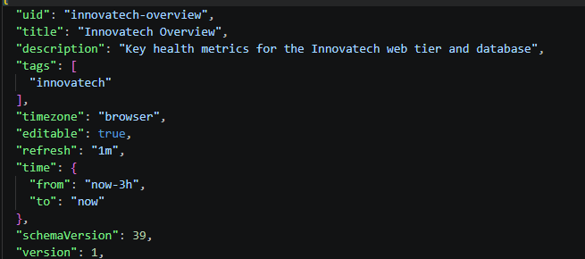
Figure 8: grafana-dashboard.json: start of the dashboard definition

2.5 Grafana Admin Password
Terraform generates a random 24-character admin password and stores it in SSM Parameter Store as an encrypted SecureString, in the same way as the database passwords. It is never written in code, and an administrator can look it up in the AWS console when needed.
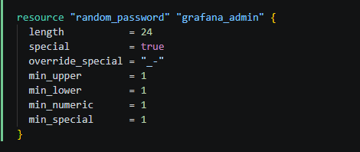
Figure 9: 3-secrets.tf: generated Grafana admin password
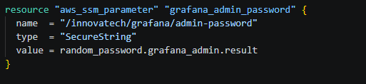
Figure 10: 3-secrets.tf: password stored as a SecureString parameter

3. Deployed Monitoring (AWS Console)
The innovatech-monitoring instance is Running with only a private IP address (10.0.3.171, in the monitoring subnet). It has no public IP or DNS name.
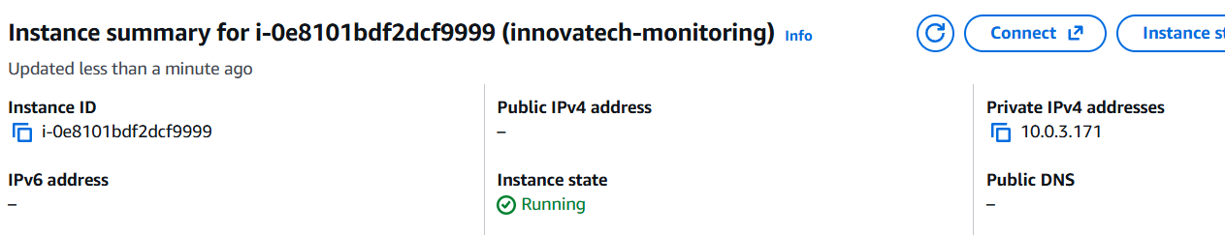
Figure 11: AWS console: monitoring server running with a private IP only
The Grafana admin password exists in Parameter Store as a SecureString. Its value is not shown.
Figure 12: AWS console: Grafana admin password stored as SecureString

4. Monitoring Is Working

4.1 Prometheus Targets
Prometheus' Target health page shows all four targets UP: Prometheus itself, the database server and both web servers. Each was scraped within the last minute. The web and database servers were found automatically through EC2 discovery. Their labels show the instance IDs from the relabelling rule.
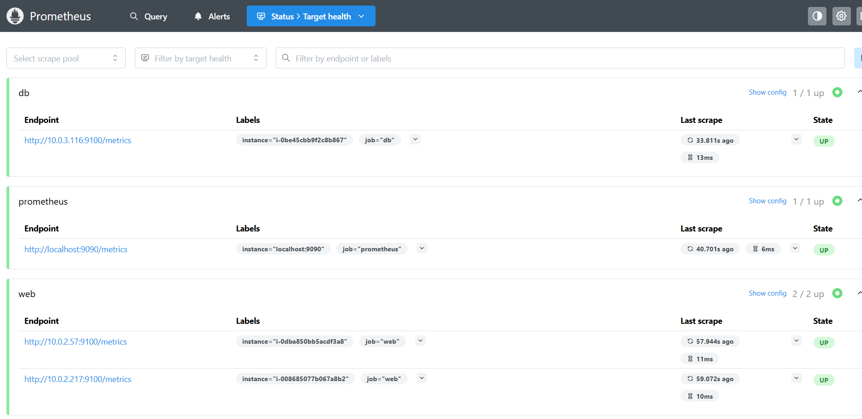
Figure 13: Prometheus: all 4 scrape targets UP

4.2 Grafana Data Source
Grafana shows the Prometheus data source, created from grafana.yml and marked as default, with no manual configuration.
Figure 14: Grafana: provisioned Prometheus data source

5. Dashboard with Key Metrics
The Innovatech Overview dashboard is loaded automatically into the Innovatech folder. It shows overall health first, then the detail per server.

5.1 Health Overview, CPU and Web Servers
The top row shows the most important information at a glance. Each tile turns orange or red when a value needs attention:
• Targets up / Targets down: whether every monitored server is reachable (4 up, 0 down).
• Web servers: how many web servers are running (2, the Auto Scaling group minimum).
• Database: UP or DOWN.
• Web tier CPU and Database CPU: orange above 60% and red above 80%, the high-CPU alert threshold from the monitoring design.
Below the tiles, "CPU usage per server" shows every server with a dashed line at 80%. "Web servers running" tracks the size of the web tier over time, so scaling events and server replacements show up as steps.
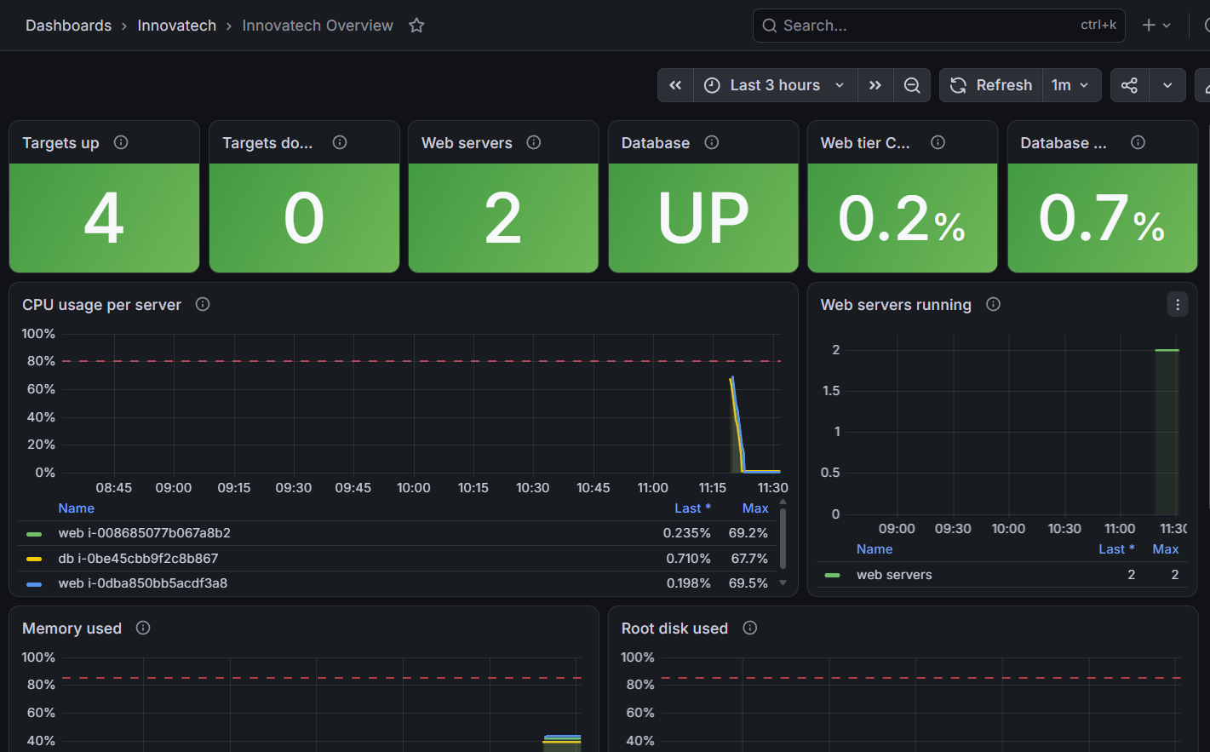
Figure 15: Grafana: Innovatech Overview, health tiles, CPU per server and number of web servers

5.2 Memory, Disk, Network and Load
The second half of the dashboard shows resource usage per server:
• Memory used: around 40% on every server.
• Root disk used: 20–26%, with a dashed line at the 85% disk alert threshold from the design. A full disk would stop MySQL from writing.
• Network traffic: bytes received and sent per server.
• System load: processes waiting for CPU. Values above the number of vCPUs would mean a server is overloaded.
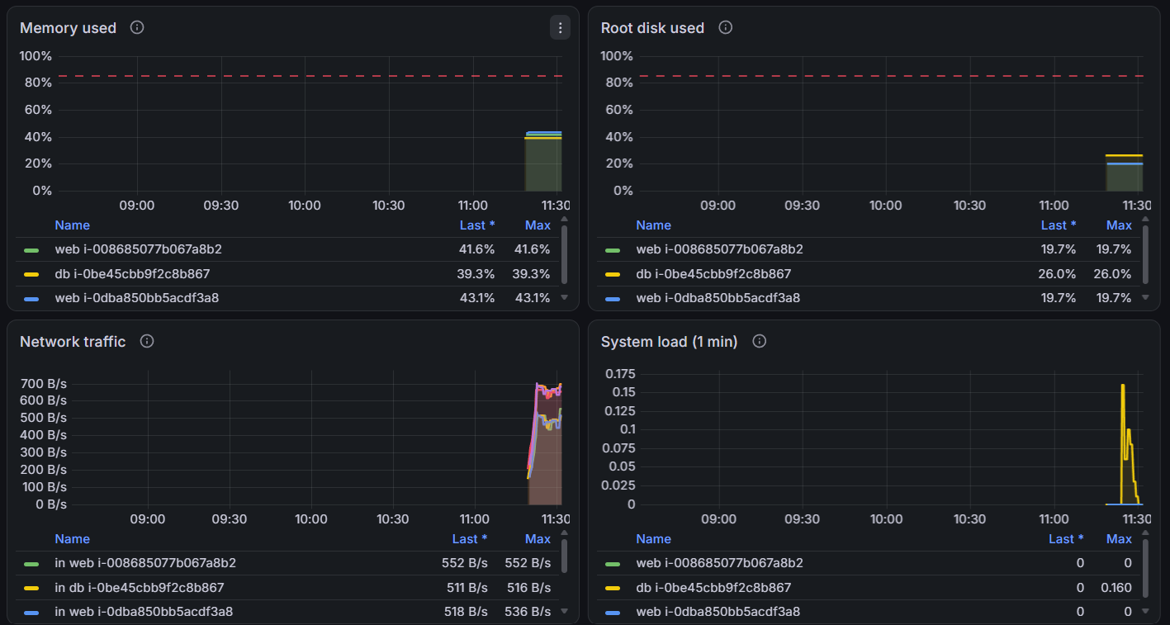
Figure 16: Grafana: memory, disk, network and load per server

Summary
The monitoring solution is defined entirely in configuration files: Terraform for the server, IAM and password, plus prometheus.yml, grafana.yml, grafana-dashboards.yml and grafana-dashboard.json. It installs itself on a private server that nothing can connect to, and finds web servers automatically as they scale. Prometheus is collecting from all four targets. The Innovatech Overview dashboard shows the key metrics in one place: target and database health, number of web servers, and CPU, memory, disk, network and load per server.

